SilentFiber Wave Baffle Installation Guide:
Step 1: Locate the area in which your baffles will be hung
Step 2: Clean the provided cables with a damp rag or washcloth
Step 3: Run 3 cables through the ceiling grid (for 1 baffle), placed approximately 4 feet apart
Step 4: Starting with the center hanger, hold the baffle up to the bottom of the cable and connect center hanger with center cable
Step 5: Pull cable through the hanger until it is tight and at the appropriate height
Step 6: Repeat steps 3 & 4 for the second and third cable/hanger
Step 7: Using a leveling tool, check to make sure your baffle is even
Step 8: to loosen or detach the cable from the hanger, pinch in the plastic sides of the hanger

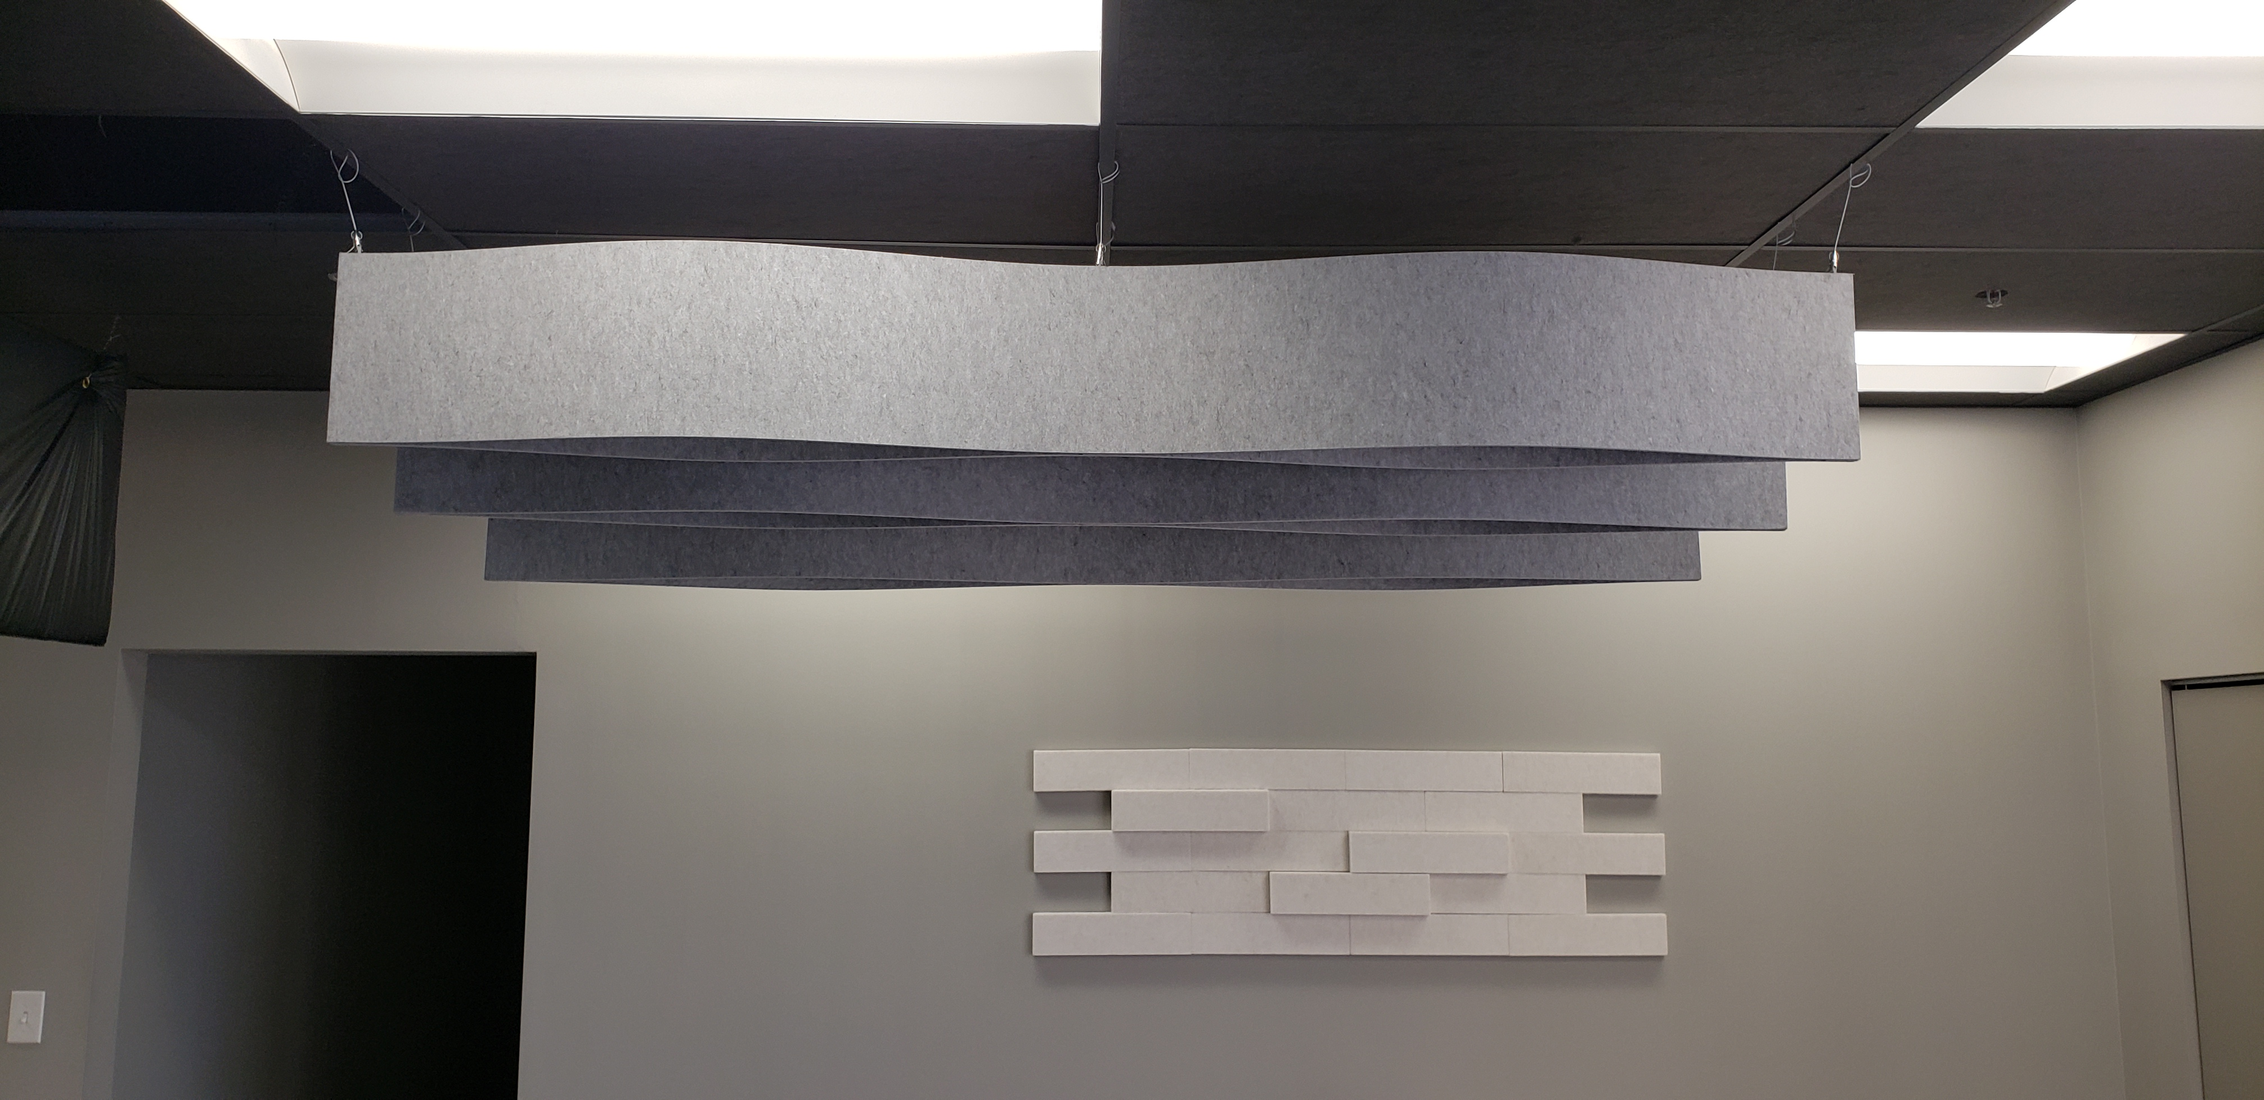
For more information:
info@soundacousticsolutions.com
www.soundacousticsolutions.com
Call toll free: +1 (877) 399-9697
Follow us on social media:

